“Momentum” App proposal

More detailed information
- Wireframes
  - Password: “MooreW19”
  - https://xd.adobe.com/view/53c11fa7-96fd-4436-5809-d2b13057e3a4-25f0/
- Spreadsheet of systems, detailed asset, and sequence descriptions
  - https://docs.google.com/spreadsheets/d/1uFAgmoXYfFGFwlk5GFbex1QyvMfLAB0633j2XYURw9c/edit#gid=0
- Spreadsheet of tasks and rewards:
  - https://docs.google.com/spreadsheets/d/1y49oo6CqNBe8wq3LxUwxyu0n6EG47pe3C-3sw9KYRA8/

Summary
“Momentum” is a habit-tracking app which focuses on the user maintaining and improving 5 broad categories of behavior (mindset, physical health, emotional health, relationships, career), instead of worrying about each particular habit.

Theme
The app is strongly themed: each behavior category (or “core”) is a system in a rocketship.
The user flies the rocketship on journeys to moons, planets and star systems, which take days of real time to complete. These journeys require the user to check in each morning to turn on the rocket’s power, and each night tally success in their habits to determine the rocket’s momentum. There is no navigation, just a straight line from start to finish. At the end of each successful journey the user is rewarded with powers, bonuses, and improvements to the ship. Then the user starts a new journey!

Progression
A controlled progression system helps users start at an easy pace and ramp up expectations over time. The primary example is that, at the beginning, users are only expected to work on one or two “cores” each day to power the rocket. Advanced users are expected to be working on 3 or more cores each day. This is reflected in journeys: traveling from the earth to the moon is easier than traveling to a new star system.

Motivation
In addition, the app includes a motivational element, which gradually pushes the user to fill out simple text lists of useful and important information.
The user begins with just a pre-written “mantra”, but over time they will be encouraged to name people that matter to them, write things they are afraid of, strengths, etc. These will be reflected back in daily and weekly flows as reminders of what’s important.

User flows
Two daily check-in’s: The user is encouraged and expected to use the app twice daily.
- Morning check-in
  - [Possibly introduce a daily challenge]
  - Choose which “cores” to work on that day
  - Review “mantra” and/or other inspiration
- Nightly check-in
  - Write a sentence each about the best and worst thing of the day.
  - Inside each active “core”:
    - Tag any habits completed in the core today
    - Rate core for the day
Journey: The user is always trying to complete a “journey”.
- Journey beginning [triggers before the morning check-in, if there’s no active journey]
  - See the new goal location
  - Receive a quest
  - Create a new entry for a motivational list (cockpit list)
- Journey finished [triggers at the end of the nightly check-in, if completed]
  - Reach and show the location
  - Receive reward
  - Check the completion of any active quest (and receiving reward if complete)
App first time launch: There is a unique flow the first time the user launches the app
- Introduce the rocket
- Introduce the cores
- Introduce the mantra/cockpit
- Introduce the journey concept
- Begin the first journey
There are a handful of simple 1 or 2 screen flows
- Special daily challenges may be handed to the user during the morning check-in
- The user can add/edit/remove new habits
- The user can add/edit/remove list entries
- The user may use bonuses and rewards to:
  - Change text in lists or space objects,
  - Change/improve the look of the rocketship
  - Influence the journey system. (A user can do poorly in their journeys if they don’t keep their core scores up.)

Screens
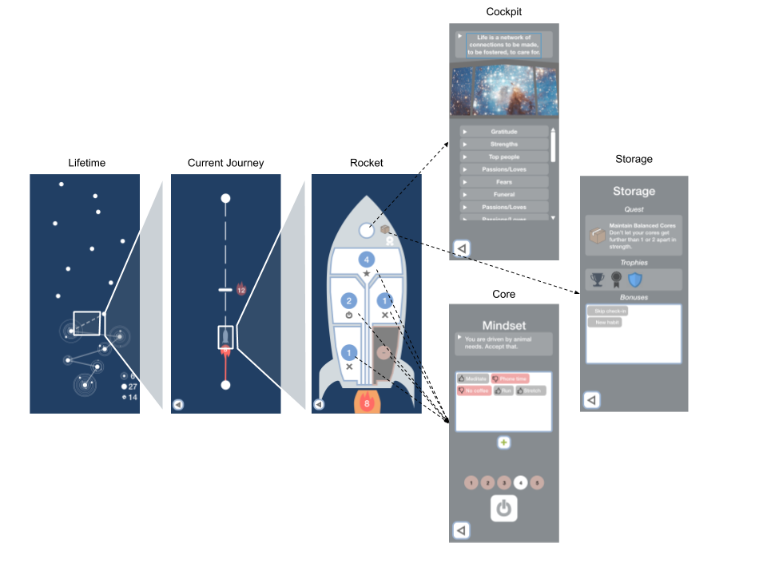
The app is split into 6 primary screens:
- Lifetime Progress - A map that is uncovered over time as the user completes journeys. (A rewarding screen, not a functional part of the experience.)
- Current Journey - The goal, the days remaining to reach it, journey progress, score requirement to reach the goal, halfway checkpoint
- Rocket - Cores overview, cockpit, storage, and overall momentum.
- Core Screen - (The same template for each core) Shows an inspirational statement, the habits, and the score meter for this core.
- Cockpit - Motivational lists that the user can edit and unlock over time, including “mantra”, a list of pre-written paragraphs that will be shown to the player each morning.
- Storage - Holds rewards, trophies, and bonuses that the user has earned. Some may be “spent” to help the user in various ways.

Interaction
- The user mostly taps on clearly defined objects to activate or enter them.
- The user may pinch-zoom between the “lifetime progress”, “current journey”, and “rocket” screens.
- There may be an additional swiping or dragging behavior during the nightly scoring sequence.

Data

“Cores” (5)
- A broad pre-defined category signifying a personal life concept (mindset, relationships, physical health, emotional health, career)
- Has an icon/image associated with it
- Contains habits.
  - Can visually hold 10-15 habits.
  - The user can add/edit/remove/(possibly hide) habits.
    - [Adding habits may be controlled by an in-app currency.]
- Has a score that reflects the user’s success in the core.
  - Has a value from 1-5
    - [This value may be modifiable by rewards/bonuses]
  - The user can influence the score once per day.
  - The score is determined by a combination of:
    - The user’s self assessment during the nightly check-in
    - AND an equation that determines how much the score can drop or rise per day.
- Can be powered on during the morning check-in.
  - If it’s not powered, can still tap habits, but cannot score this core.

Habits
- A simple 32-character string.
- Can be tagged “good” or “bad”.
- During the nightly check-in: can be tapped to toggle whether or not it was completed that day.
  - Any “completed” habit resets to “incomplete” the next day.
  - The app should store the days each habit was “completed”.
- A pre-written set of 10-15 habits will exist for each core that the user can select.

Lists
- A simple text entry system
- Each list is provided to the user with an un-editable name
- Divided into different entries:
  - Entries are user controlled.
  - Most lists start with zero entries
  - Each entry can contain a lot of text.
  - Entries support multi-line and the return character.
  - New entries are prompted during user flows OR may be manually entered by the user.
    - [Adding new entries may be controlled by an in-app currency.]
- Lists can be tagged with one or more core.
- There will be a couple lists with slightly unique properties, like the “mantra” list, which may not visually divide.

Travel/Tasks
- “Momentum”
  - The sum of all cores that are “powered” or “active” in a day, as chosen during the morning check-in.
    - A limit to the number of active “cores”.
      - Starts at 1
      - Can be increased permanently or temporarily with certain rewards.
  - Represented by the size of the jet emanating from the rocket.
- Journeys
  - The rocketship is always making a “journey” from one place to another
  - Each journey has:
    - Days to complete
    - Total core scores requirement to reach the location
      - The user is evaluated at the halfway point in the journey whether they succeed or not.
    - A starting point and goal (places)
    - A reward for reaching
- Places
  - Planet surface, orbit, space stations, moons, planets, star systems
  - Each of the above have unique
    - Visuals (small and large art assets)
    - Identifying text
    - Take different amounts of time to reach
    - There should be 3-7 varieties of each
    - These may change the backgrounds on various screens
- Quests (10 variants)
  - The user will be given certain optional tasks.
  - Completion of tasks give rewards and bonuses
  - Types
    - Challenges - Short, 1-day
    - Quests - Last the duration of the journey
  - Tasks (10 or so)
    - Maintain balanced cores
    - Add X number of new list entries
    - Excellent performance
    - Go outside your comfort zone in the real world
  - Some tasks may be tracked by the app, others may be self-assessed (like real world activities the user is asked to do)
- Rewards/Bonuses (10)
  - The user finds and earns rewards and bonuses which makes the rocketship better and better over time.
  - Some rewards are temporary, others permanent ship improvements
  - Some systemic, value increases, etc, other rewards purely aesthetic
  - Examples:
    - Increase the amount of “active” cores
    - Increase the meter size for a core
    - Negate a missed check-in
    - Change the rocket’s colors

